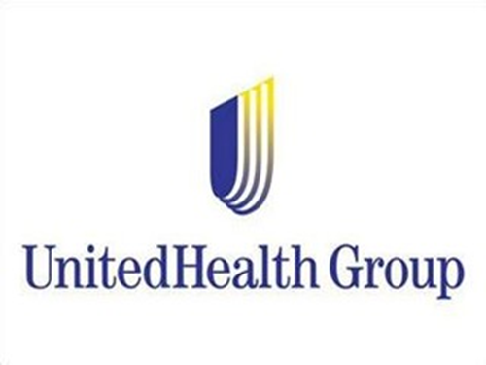

Business Plan for UnitedHealth Group Inc. to enter China’s $476 Billion market for managed healthcare services through a joint venture with Ping An Health Insurance Co., Ltd

Executive Summary

It is recommended that UnitedHealth Group Inc. enter China with its managed health care services through a joint venture with Ping An Health Insurance Co., Ltd.
[Placeholder - Executive Summary. Use the above as the opening sentence (mandatory).

Table of Contents

Introduction 4
Company Description 4
Company Strengths 5
Company Weaknesses 6
Global Industry Description 6
Country Selection Rationale 10
Country Comparison 10
Summary Rationale for Country Selection 15
Target Market Size 17
Competitive Risk/Advantages 18
Risk Mitigation Strategies 22
Opportunity for Exploitation 23
Entry Strategy Legal Structure 24
Entry Strategy Organizational Structure 30
In-Country Marketing Plan 39
Financial Value 49
Balanced Scorecard 54
Conclusion 54
Reference List 55

Introduction

[Placeholder – Section 1 - Introduction]

Company Description

UnitedHealth Group Incorporated (UNH) is a managed healthcare company specializing in a diverse range of offerings related to the well-being of customers. UNH maintains and operates as two distinct subsidiaries: UnitedHealthcare and Optum. These main product lines branch out into several discrete segments, including pharmacy services and health data analytics. UNH focuses on providing services to individuals and employers. UNH also offers Medicare products for people aged 65 and older.
UNH operates in a competitive industry, facing a strong rivalry from other companies in the managed health care field, such as Aetna, Anthem, Cigna, and Humana. Together, these companies lead the top five managed health service providers in revenue for the most recent fiscal year, with combined reviews of over $385 billion (“Fortune 500”, n.d.). The industry boasts a large market cap of over $640 billion, with an average dividend yield of +1.26%, and an average return on investment of 8.94% (“Health Care Providers”, n.d.). The industry is also doing well in revenue growth, up 11.41% from the previous 12 months.
The focus of the market expansion is to extend the reach of the UnitedHealthcare (UHC) business segment into the foreign market with the best conditions for success. Specifically, the focus is to market individual or business medical health care plans in a BRICS+N11 country. These plans will be custom packaged and priced to provide the greatest health care benefit possible and to allow the population access to an alternate network of medical providers.
The packages include health insurance, with optional services to include dental and vision. The intention is to give buyers more cost effective healthcare provider choices, without sacrificing quality. Buyers purchase insurance plans from UHC to access the network of providers for cost comparisons, which aides in reducing out of pocket expenses. Additionally, UHC offers and delivers value-based care to clients, rather than the dated traditional health care service received by clients today. Value-based care places the patient at the center of the health care experience (“About Value-Based”, n.d.). The new value-based system focuses on proactive care through the use of preventive measures, with an emphasis on keeping consumers healthy (“How Value-Based”, n.d.).

Company Strengths

UNH recently reported that it has over 75 million customers in the national and international markets (UnitedHealth Group, 2011). The American Medical Association listed Ingenix, now Optum, as the pioneer in electronic health records system as of 2010 (UnitedHealth Group, 2011). UNH is a diversified company that offers health care solutions to its customers. Its multiple business segments offer diverse portfolios to its large customer base nationwide that differentiates it from its counterparts. Their portfolio, in turn, leads to an increased customer base each year. For example, by the end of 2009, it had around 70 million clients in the domestic and international markets and now has over 75 million customers (UnitedHealth Group, 2011). UNH shows exceptional financial stability in the markets. Additional strengths include its strong brand, as acknowledged by being named the #1 most admired company in its segment by Forbes, and its mobile care delivery options via Optum.

Company Weaknesses

Since 1995, UnitedHealth Group has acquired other related businesses to maintain its competitive advantage in the domestic markets. One of its recent acquisitions includes Health Net Inc. (HNC). UnitedHealth Group paid 500 million US dollars over two years for the purchase (Wall Street Journal, 2009). This, and other historical investments, has improved the revenues generated by the company, but these acquisitions have also increased UNH’s level of debt and the administrative costs of doing business.
According to United States Securities Exchange Commission’s filings, UNH maintains its operations in 15 local markets of 11 different states in the US. This makes it vulnerable to the changes, whether governmental or social, happening in multiple jurisdictions around the country. Any of these changes can have a great impact on the company’s market position and its profitability in the long run. Additional weaknesses include UNH’s focus on acquiring smaller practices, the high cost of patents in research & development, and the heavy amount of government regulation surrounding the industry.

Global Industry Description

The healthcare industry is a very broad and diverse space. This industry covers hospitals, pharmaceuticals, diagnostics, medical equipment and health insurance. Within each of these sub-industries are more specialized markets such as manufacturing and distribution under pharmaceuticals or public and private under hospitals.
Developed markets face aging populations and increasing chronic diseases while developing countries must combat chronic diseases and the lack of healthcare resources, which forces the costs of health care to rise. These rising costs increase the attractiveness of expansion into the health insurance segment of the healthcare industry. Globally, health insurance is big business, bringing in an estimated $842.1 billion by 2017. Healthcare spending is forecasted to grow over 6% a year in 2017 and 2018, driven mostly by markets in Asia and the Middle East (WIO, 2015).
Despite the United Nations’ initiative in 2015 to standardize healthcare globally, the government provided public insurances have different coverages country to country, with many funding shortfalls and subpar quality care (Dain, 2015). The difference between the needs of the patient and the scope of the public insurance has generated the need for private insurance to cover the gaps, creating opportunities for individuals with disposable income to gain access to the quality care they require.

Rivalry Among Established Competitions
The level of competition among the existing firms in the industry is very high. The top three competitors of UNH are Aetna Inc., Humana Inc. and Anthem Inc. (Hoovers, 2011). Other global rivals are Allianz, AXA, Bupa Global and the Zurich Insurance Group. The success of these competitors is dependent on the accuracy of cost predictions for a proposal. The profit margins of the competitors are conditional to their marketing plans and on their abilities to accurately estimate the future premiums (Hoovers, 2011).
The Bargaining Power of Suppliers
The bargaining power of suppliers is derived by their power to demand the prices of their choice. In the insurance industry, this threat is low. However, the dependence on human capital does exist in the industry. The ability to attract quality resources threatens the health insurance industry. For example, the insurance company associated with the most popular hospital in the area will have more customers in that specific area. Also, companies must remain vigilant to keep talented doctors or personnel from being poached by larger companies.
The Bargaining Power of Buyers
The threat of the bargaining power of buyers is considered low. The large corporations similar to the airline and other related business pay large sums of money as insurance to these companies. These market players in the insurance industry strive to obtain high margin, corporate clients.
The Threat of Substitute Products or Services
Also low is the threat of substitutes in the healthcare insurance industry as there are few substitutes available in the market. Globally those individuals with private insurance generally have it through their employer. The opportunity to substitute is only available to those who are self-employed or self-insured. For these people, there are few options, such as primary care memberships, medical cost- sharing programs and health savings accounts (Maverick, 2016). These options are only available in a few of the developed countries and not in the BRICS +11 countries.
The Threat of the Entry of New Competitors
This industry imposes certain barriers to the entry of new companies in the markets. These barriers ensure that the level of threat of new entrants is remains low. Any new companies must comply with restrictive governmental regulations to make their entry in the markets. Some other obstacles are tariff rates, high capital requirement and distribution channels.
Government Influence
The Government has regulated the healthcare industry for some time. The HMO Act of 1973 requires that companies have to offer HMO’s as an option for company healthcare. This HMO choice gives the employee the opportunity to receive care from specialized networks at a lower cost. Since 1973, Congress has updated the HMO Act to allow companies some flexibility in determining their HMO contributions (Carlstrom, 1994).
The Certificate-of-Need (CON) law of 1974, requires states receiving federal funds to review and approve any planned capital investments by local health care institutions (Carlstrom, 1994). Once this law was rescinded in 1986, the government focused its influence in the health insurance industry on social welfare programs like Medicaid and Medicare (Carlstrom, 1994).
Technology Trends
Traditional care is changing largely because of technology and the ability to reach the consumer quicker and more conveniently. Companies are creating low-cost ways to track and monitor health issues, provide medication at a lower premium and increase remote capabilities. For example, “services like Heal and Pager enable patients to order on-demand concierge medical services to their home” (Beckland, 2016). The technology companies are developing dissolvable sensors to go inside medicine that transmit data to the physician's office to better track and manage the patient’s medication intake. These new offerings are pushing the healthcare industry forward.

Country Selection Rationale

The fast-paced emerging markets and high growth of the BRICS and N11 regions have attracted international corporations to invest heavily in their development. Nearly all industries are experiencing growth, but the field of healthcare makes arguably the largest impact considering the number of the population that it affects
. Criteria used to narrow the field down to two countries include political stability, economic conditions, environmental stability, average income levels, and technology infrastructures. A PESTEL analysis has been conducted to examine the macro-level environments for doing business in each country environment that will affect opportunities and risks. (See Appendix A)

Country Comparison

It is estimated that three billion people will join the middle class by the year 2050; and, most of that increase will come from the emerging market economies (EMEs) (“Keep Healthy”, n.d.). According to Moura and Moura (2016), approximately 80% of the global population live in EMEs and do not have sufficient healthcare (p. 33). China’s and South Korea’s, increasing middle class, have been identified to have the best expansion opportunities.
Opportunity Support
Political
China is working to reform its healthcare infrastructure to include many initiatives such as improved healthcare quality, increasing patient health care knowledge, and reforming public hospitals ("Report Recommends Deeper Healthcare", n.d.). South Korea offers national health insurance (NHI), however the medical assistance program covers only 3% of the total population (Sohn and Jung, 2016, p. 2).
Economic
Health expenditures accounted for 7.4% of GDP in South Korea and 5.5% of GDP in China (2014) (“World Factbook – Central Intelligence Agency, n.d.”).
Social
Current population size in China is 1.3 billion with a .43% growth rate and South Korea 50.9 million with a .53% growth rate ("World Factbook — Central Intelligence Agency”, n.d.). The aging over 65 population of China, estimated to exceed 200 million by 2030, supports the need for new healthcare options ("Report Recommends Deeper Healthcare Reforms in China," n.d.).
Technology
The reported LPI scores of China and South Korea are 3.66 and 3.72 ("Global Rankings 2016 | Logistics Performance Index," n.d.). These scores are relatively high and indicate that the current infrastructures of China and South Korea support an expansion by UHN.
Environmental
A recent environmental performance index (EPI) reports that half the world’s population lives with unsafe air and one-third of that number represent the residents of China and South Korea where 50-percent of their residents are exposed to “unsafe levels of fine particulate matter” ("Global Metrics for the Environment. The Environmental Performance Index ranks countries’ performance on high-priority environmental issues," 2016).
Legal
Under the supervision of the National Health Insurance (NHI) program, which is operated by the NHI Service (NHIS), the Korean government offers health insurance to all its citizens as well as a free medical assistance program for those who meet low income requirements (Sohn & Jung, 2016, p. 1). The program is successful; however, the Korean government is considering the expansion of private health insurance (p. 2).
Risk Comparison
Threat Factors and Trends
The key industry factors and trends that affect the general level of competition are supplier power, buyer power, competitive rivalry, threat of substitution, and threat of new entry. UNH’s competition in the industry is moderate to strong with Aetna, Anthem, Cigna, and Humana as competitors. Threat of substitution not only comes from other providers, but the social insurance option offered by the government in the form of universal health care or national health insurance.
Threat Factors & Trends: General Level of Competition (Porter’s 5+2)
Porter’s Five Force Model is a market investigation instrument that looks at five forces, or factors, that can influence a company’s operations in the market (Porter, 1979). These five factors provide opportunities and threats that will be unique to the company and the industry.
Bargaining Power of Customers
The medical insurance industry is relatively unaffected by individual buyer power because most do not self-insure. Most consumers are given a choice of insurance options through their employers or the government. Large corporate clients have a lot more bargaining power with insurance companies (Geisel, 2004). This holds true more so in China and South Korea due to their government insurance plans that provide universal health care. These plans do not give the consumers an option on plan providers.
Bargaining Power of Suppliers
The suppliers for the insurance industry can run the gambit from IT service providers for the office and administrative work to doctors and hospitals in the network. Suppliers are powerful regarding prices and quality. They can put the industry under pressure by using these factors. The fewer suppliers there are in the market, the more influential the existing suppliers are. For both China and South Korea, the main pressure point is the human capital. Talented healthcare personnel and insurance underwriters are hard to come by in both countries (China Briefing, 2015). The resource pool is very limited which can cause stiff competition on obtaining their services (Lethbridge, 2011).
Threat of New Entrants
The new competitors in the medical insurance industry can include financial services companies as well as other insurance companies. The barriers for the average businessman are very high because it is very expensive to start up a firm and government regulations are very complex.
In some countries, governments can impose high taxes and tariffs on foreign investors to protect domestic production. China has created a (Shanghai) Pilot Free-Trade Zone in late 2013 to attract foreign investment into the healthcare sector (China Briefing, 2015). Although foreign investment is welcome in South Korea, the red tape and bureaucracy have hindered the entrance of many foreign businesses in the healthcare sector (State, 2015).
The Threat of Substitute Products
The substitute products for this industry are few. The widespread use of the internet giving access inexpensive access for buyers to pharmaceuticals and medical consultations could detract from the use of traditional healthcare which would negate the need for insurance. Traditional medicine (Chinese and Korean) or consortiums that cost share for medical expenses are two other possible substitutes seen in the Asia market. In Asia, the local practitioners who provide these treatments do not belong to the traditional health care network and therefore do not fall under the purview of medical insurance.
Level of Competition in the Industry

In both China and South Korea, the competition is extremely high because the main competitor is the government. Universal healthcare is provided by the governments to everyone and covers the majority of the population’s basic needs. It can be very hard to convince someone to pay for something when he can receive it for free (Lethbridge, 2011).

Summary Rationale for Country Selection
Threat Factors & Trends: Other Threat Factors (PESTEL Table)
(See Appendix B)

Recommended Country for Entry
After careful deliberation, the more attractive marketplace is in China. With a population that exceeds 1.3 billion people and a land mass much larger than the United States, China's size and scale presents advantages uniquely distinct from any other market (2009). China's healthcare market is expected to boom over the next decade, driven by the country's giant economic expansion and its burgeoning senior population (Shih, 2014). Based upon the PESTEL analysis, UNH entering the Chinese market will be the best opportunity for expansion.
China Selection Analysis
From a political standpoint, the Chinese government is making major strides to alleviate the obstacles in place for private healthcare companies. Policymakers are finding the value in lifting restrictions and sanctions on the market which will directly affect the entry of UNH. For example, “One major barrier was the regulation barring physicians from working at multiple sites, which made it difficult for small private hospitals to offer an attractive enough salary package for skilled physicians to quit their jobs in the public healthcare sector” (Waldmeir , n.d.). Lifting sanctions essentially allows companies to raise the level of competition in the market.
From an Economic standpoint, the economy in China grows at a higher rate, inflation rate is lower and it’s a significant difference between the population of citizens who live under the poverty line. Around 6% of Chinas citizens live under the poverty line while nearly 15% of South Korea’s population lives under the poverty line.
Risk of Entering China
One great risk of entering China is the lack of qualified doctors in their network. An article in the South China Morning Post stated, “Doctors are chronically overworked and underpaid. Hospital administrators struggle to meet shortfalls between government reimbursement and increasing costs"(Shih, 2014). With overworked and underpaid doctors, it increasingly becomes a concern for fraud and bribes within China.
While regulations have eased there are still the Chinese government have done little to address the growing infrastructure concerns. “To actually execute in China, you still find that a lot of foreign companies require some sort of local partner either for real estate or licensing reasons or for access to particular referral services” (Johnson, n.d.).
Lastly, the increasing cost of medicine has put a damper on the industry and continues to be one of the greatest hurdles to overcome for companies wishing to enter the market. The corruption surrounding this topic has gained national attention and there has been little done to remedy the the issue. Chinese hospitals typically put a 15% mark-up on drugs which makes it hard for patrons to pay for their medication. While the Chinese government have tried to put sanctions on the drug industry there are still loopholes that allow companies to hike prices which make it difficult for new companies to enter and remain competitive.

Target Market Size

The target market is the emerging middle class, specifically those aged 25 to 54 living in China that are affected by diabetes or pre-diabetes. According to 2016 estimates by the Central Intelligence Agency (CIA), Chinese aged 25 to 54 represented 48.42% of the total population, or 663 million. Results from a sampling survey completed by the Journal of the American Medical Association indicate that 11.6% of the adult population is diagnosed with diabetes (Xu, Wang & He, 2013). In addition, another 52.1% of adults are estimated to have pre-diabetes. Xu, Wang and He summarize these findings by concluding that up to 113.9 and 493.4 million adults have diabetes and pre-diabetes, respectively, totaling 607.3 million. Since adults aged 25 to 54 represent 48.42% of the total population, the middle aged diabetic/pre-diabetic market is approximantely 294 million people.
According to a survey, the national average monthly premiums for a 25 to 54-year-old amounts to $159 per month (“Age & Health”, 2012). Since UNH will be leveraging economies of scale and passing on savings directly to the consumers, premiums will be 15% less for the target market, or a realized savings of $24 per month. Therefore, UNH has a target market of $476 billion. Various underwriting factors influence premium price, such as age, preexisting conditions and exact location.
Finally, according to the International Diabetes Federation estimates, around 151 million adults in China are expected to be diagnosed with diabetes (excluding pre-diabetics) by 2040 (Sjolin, 2016). This represents a 33% increase from 2016, accounting for an additional 37.1 million consumers. Additionally, this represents a steady annual increase of around 1.38% for the next 24 years. In 2021, the primary diabetic target market will be around 121.8 million consumers. In dollar value, this equates to a target market, excluding pre-diabetics, of around $197 billion. The existing market, excluding pre-diabetics, stands at a valuation of $184 billion.

Competitive Risk/Advantages

The health care industry is very competitive and UNH does not lack in local or global competition. With current presence in Brazil, Portugal, the United Kingdom, Czech Republic, and 30 countries in South Africa, UNH’s competitive strategy has been “to provide products based on the local infrastructure, culture, and needs” (Patrick, 2015). In addition, the healthcare industry competition can involve price, quality, convenience, or better service (Rivers & Glover, 2010).
The greatest risk to UNH to expanding into China comes from the current political and public health systems. The Chinese government plans to offer “affordable and equitable basic health care for” its citizens by the year 2020 (Yip, et al, 2012, p. 833) and “despite its size and heterogeneous environment, China has made big strides towards providing its population basic health care” that is inexpensive and impartial (Yip et al., 2012, p. 840). Chinese government operates under a lack of transparency and is well known for corruption (Jayaraman, 2009, p. 55) with a disregard for patents and business laws that are regulated in the west (p.56). Further risk to UNH’s expansion is the Chinese culture and views on the market place. The Chinese view the market place a “battlefield” (Jayaraman, 2009, p. 56) and the “sharing what they created with society to promote greater harmony” (Jayaraman, 2009, p. 56) viewpoint is credited with the society’s disregard for copyright and patent laws.
The next risk comes from the strong competitors with current Chinese healthcare market shares. UNH’s local competitors Humana Inc, Ping An Health, United Family Healthcare, Chinese Government Universal Healthcare System, Chinaco Healthcare Corporation, and Cigna. Global competitors include Zurich Insurance Group, Allianz, The Artemed Group, Aetna, International Healthcare Providers, and AIA.
Local Competitors | Strengths | Weaknesses
Humana Inc. | Multiple health insurance options including Medicaid and Medicare. | Limited health insurance coverage globally. Not currently established in China.
Ping An Health | Second-biggest insurance carrier with will-established networks throughout China. Understanding of local societal mores, government bureaucracy, and Chinese market. | Health insurance options are difficult to understand and lack differentiation.
United Family Healthcare | All facilities are accredited through the Joint Commission International (JCI). 20 years in the Chinese market. Diverse programs. | Newer hospitals have four times the current capacity. Country’s health related marketing is censored. Disputes over service provided have resulted in violence at some facilities.
Chinese Government Universal Healthcare System | Total market control. Guaranteed finance through mandatory participation. Gives consumers a choice between public and private insurance. Choosing private insurance frees up resources for the government to provide better serves to those that are a part of the public system. | Inefficient with inadequate services, overcrowded hospitals, and overworked doctors. Gaps in public health system that leave the citizens paying for health-related services without reimbursement. Private health insurance often offers better options.
Chinaco Healthcare Corporation | Already established in China with cultivated relationships with the people and the Chinese government. Utilization and knowledge of Chinese medicine practices. | Low ROI with only 70% of the business. Rapid growth of the company difficult to manage while simultaneously penetrating the market.
Cigna | Already established in China. 15 million global medical customers. Ranked 90th on Fortune 500 list. One of the 100 Best Corporate Citizens as recognized by CR Magazine. | Does not offer work play insurance in China.
Global Competitors | Strengths | Weaknesses
Zurich Insurance Group. | Global market experience | Limited healthcare insurance options
Allianz | E-commerce platform, Allianz 360, which gives customers the ability to research and verify policies as well as monitor claims. Well established network of healthcare providers and partners. | Healthcare insurance is the strongest asset in the company. Very high employment turnover rate.
The Artemed Group | Takes advantage of the advent of new technology. Opening a new facility that is expected to be the model for high quality, affordable care. | Government restrictions on healthcare related marketing. Lacks accreditation (two years to become accredited by JCI). Want to switch to the German-like DRG payment model which fixes prices for patients, but transfers the economic risks to the healthcare providers.
Aetna | Currently established in China for the last 24 years with in-depth research that has allowed for tailor made offerings to the customers. Largest commercial insurance group in mainland China. First to offer 100% coverage under its Health Asessentials brand. | Limited financial ability to compete with the international expansions of their competitors.
International Healthcare Providers | Utilization of a vetting process to ensure the best healthcare centers around the world. | Patients are sent worldwide for services and there are cost considerations, like travel, outside of the medical services.
AIA | 37-percent new business growth in 2016. Largest independently listed insurance group in the Pan-Asian area operating in18 markets in that region. | Most of the services are insurance and asset protection not medical coverage insurance. Health related coverage is limited to disability and critical illness which can only be active in certain situations.

Risk Mitigation Strategies

One of the major threats identified in the previous PESTEL analysis is the lack of qualified doctors in the country. According to the World Health Organization, China exhibited only 1.5 doctors per 1000 residents in the country (“GHO”, n.d.). To put in perspective, the US averaged 2.6 doctors per 1000 residents, while Germany, home of TAG, averaged 4.7 doctors per 1000. Additionally, in some rural areas there is less than 1 doctor per 1000 residents on average (Jiang, 2011). Secondly, the glory and prestigious characteristics once associated with the doctor profession are fading, as qualified candidates are reluctantly no longer aspiring to be physicians. As a direct result of the violence being publicly carried out against medical professionals, the number of students enrolling in medical schools has begun to decrease (Pickrell, 2016).
All of these competitor companies have the ability to mitigate these threats, although at different costs. Some companies, like UFH, have been established in China for 20 years, and has partnered with several academic institutes that help facilitate the development of future doctors. New entrant companies must also find a partnership or affiliation with an academic institute for medicine, to secure their pipeline of future medical professionals. UNH must invest upfront to establish the relationships needed, even if it means giving up equity to invest in a joint venture partner. Regarding mitigating violence in the medical setting, all organizations must implement efficient dispute management processes. These processes must ensure transparency between medical professionals and patients, and intend to be proactive rather than the troubled reactive approach. This approach will take some time, but is necessary to build back the trust that has been lost in the hospital network.

Opportunity for Exploitation

Develop healthcare programs that target the elderly
The demands for better health services by the aging population immense. China has the largest population in the world, and it additionally has the greater number of old people. If UnitedHealth Group Inc. targets this population by developing programs that suit these people will be of benefit. A large number of clients will give the company a competitive edge as well as preference in the market.
Invest more resources towards digital health and medical tourism
Research has it that the future of healthcare is in digital health and medical tourism. In this case, the company can invest more resources to tap this underutilized market. Several people in China are connected to the internet. It means that these people can easily fit into digital health programs that will allow doctors to offer a diagnosis to patients. Digital health can be managed from some distance with only referral cases being attended to at healthcare facilities. Medical tourism is another area that can allow clients to explore health services available with UnitedHealth Group Inc. that improve diagnosis. Investment into the two regions will boost the company’s revenue and also place it among the market leaders in healthcare (Smita, 2016).
Enter into agreements with Chinese government for better treatment
There is an opportunity of entering into strategic agreements with the Chinese government to allow growth of the company in China. It is only through real political goodwill that UnitedHealth Group Inc. can be able to venture the Chinese market. When the government signs bilateral agreements, the company will be able to sell its services adequately to the Chinese population (Helms & Nixon, 2010).
Mitigating private health insurance risk
Regarding mitigating private health insurance risk, I think it is important that UNH appeal to the target group, which include a significant amount of young adults, by providing incentives for them to participate in more active preventative health measures. These not only decrease the cost of insuring these people, but provide them with a less out of pocket and premium cost overall. I think UNH could also implement a buddy cost saving system as well, where if a person brings a friend to the gym with them, then they gain double bonus points that can be redeemed for deductions. This way they are encouraging even more activity and hopefully set a positive trend. Other ideas to justify and promote the private insurance cost and the well-being lifestyle, respectively, could be to have monthly giveaways for health trackers like Fitbit or free gym memberships. UNH could also create competitions where the most active people for the month get 50% off their bill for the period. All of these things make health care appear fun, provide the perception that UNH really cares about the people they insure, and ultimately gives everyone more incentives to justify the cost of private insurance.

Entry Strategy Legal Structure

As UNH looks at expanding into the Chinese market, one of the most important choices is the type of legal structure to use. In China, the Foreign Investment Industry Guidance Catalogue is a document issued by China's National Development and Reform Commission (NDRC) and the Ministry of Commerce which governs foreign investment in Chinese companies (FDI, 2015). The Catalogue classifies foreign direct investment in various business activities as encouraged, restricted, prohibited or permitted. Any activities not listed are, in the absence of other rules to the contrary, considered to be authorized for foreign investment. The latest version of the Catalogue has changed the insurance industry to the restricted category (FDI, 2015). Investment in this category is subject to higher levels of scrutiny and stricter administrative requirements, and may be denied at the discretion of the approval authorities. This category also restricts the type of legal structures available. Direct investment is now prohibited, but both a Representative Office and Joint Venture are allowed (FDI, 2015).
Representative office
Foreign companies have traditionally used a representative office (RO) as a first step to gaining a foothold in China. An RO is not a legal entity but rather an intermediary office for the company’s headquarters’ in its home country (Pakroo, 2016). Since the RO acts as a middleman, it is prohibited from engaging in profit-making activities.
The RO cannot directly engage in any business for profit, represent any firm other than its international company, collect money or issue invoices within China for services or products nor buy property or import production equipment. ROs also cannot issue receipts or sign contracts since all legal actions the RO undertakes are on behalf of the foreign enterprise. However, the RO can conduct market research, promote products of the foreign enterprise, carry out business activities on behalf of the foreign enterprise, liaise with European clients that have a presence in China and encourage technology exchanges (EUSME, 2015).
Furthermore, ROs must undergo an annual inspection conducted by the local Administration of Industry and Commerce and tax authorities and are taxed per relevant regulations (Tian, 2016). Under normal circumstances, ROs are subject to enterprise income tax on the income attributable to them and business tax and value-added tax for their taxable income. The same rate of enterprise income tax that applies to equity joint ventures will be administered to an RO. An RO may hire employees from foreign countries which are considered to be representatives. An RO may also hire local Chinese employees. Moreover, ROs may employ no more than four foreign nationals and must apply for each foreign national’s residency (EUSME, 2015).
Joint Venture
A Joint Venture (JV) is another legal structure that foreign investors can use to create a presence in a foreign market. There are two types of joint ventures (JVs) in China: the equity JV (EJV) and the cooperative JV (CJV), also known as the contractual JV (Tian, 2016). JVs are very often the only type of company that foreign investors can utilize to engage in restricted industries in China, as stated in the Investment Catalogue (FDI, 2015).
Equity Joint Venture
An EJV is a legal entity created by Chinese and foreign partners that hold joint operations and ownership of a limited liability corporation and agreed on management and the division of risk. Companies in an EJV share both revenues and risks according to their respective registered capital contributions. In the EJV the foreign partner must contribute a minimum of 25% of registered capital (Tian, 2016).
Cooperative Joint Venture (CJV)
A CJV is a partnership between a Chinese enterprise or organization and a foreign enterprise, organization or individual (Tian, 2016). A CJV can have a formed partnership based on an incorporated arrangement with a limited liability company or be based on a contractual cooperation agreement. Foreign parties to a CJV enjoy considerable flexibility when negotiating the details of the CJV, including profit sharing, management structure, and capital investment (EUSME, n.d.).
Advantages and disadvantages of each legal structure
Joint Venture Advantages and Disadvantages
The Chinese government has stated it welcomes foreign investment, “in 2015, China’s inward FDI flow rose around six percent from the year earlier to USD 126.3 billion, according to the Ministry of Commerce (MOFCOM)” (export.gov) With recent changes in regulation, we find that China welcomes foreign investment, but to what extent? There are many concerns about potential investment returns and if the investors company will ever receive fair competition in the market. Both of which are great concerns.
What alleviates the concerns of the investing party, as well as China, is entering a joint venture with the investing company. What make joint ventures so attractive are the common objectives and benefits to both parties. It’s essentially a partnership where two or more companies can negotiate their responsibilities of that partnership. Some clear advantages to UNH establishing a joint venture in China would be the following: shared risk, combined resources, less investment cost, helping with transfer of knowledge, disabling existing ownership restrictions and bridging the gap between cultural differences. One of the best aspects of establishing a joint venture is that UNH will be presumed as a foreign national company. Merging brands with existing core missions and values create value to the partnership and ease the entry of a new entity in the minds of foreign nationals.
While there are many advantages to establishing a joint venture, there are some disadvantages that make both companies weigh their options. Some clear disadvantages to UNH establishing a joint venture in China would be the following: cultural differences, less control, coming to JV terms, determining how to split profits and conflicts over business affiliates. One of the more difficult aspects of establishing a joint venture is protecting proprietary knowledge. It’s hard to merge companies, use foreign nationals as employees and not wonder if your proprietary information is being compromised. The ability to learn from partners is very important and limiting access to your proprietary skills and information is as equally important to keep a competitive edge in the marketplace. Finding the medium where some but not all knowledge is contained is vital to the success of both entities.
Equity Joint Venture Advantages and Disadvantages
“An equity joint venture (EJV) is a limited liability corporation in which the Chinese and foreign partners jointly invest and operate the corporation” (pacificbridgemedical.com). What makes it different from a regular joint venture is that a JV is used as a partnership agreement and an EJV is when the investing company and the foreign company creates a new entity. What makes the EJV a viable selection for entry structure is that profits and risk are assumed by the percentage of equity each partner owns in the company. While there is a minimum investment of 25% for UNH, we anticipate a 50% contribution from each party. Some clear advantages to UNH establishing an equity joint venture in China would be the following: limits their liability, life term is specified in contract, profits and losses are distributed based on equity share, the preferred investment vehicle of the local government and clear laws governing the JV. Some clear disadvantages to UNH establishing an equity joint venture in China would be the following: number of board members corresponds with percent held by investor, high effective tax rate, delayed negotiations and restrictions on withdrawing any capital during contract.
Contractual Joint Venture Advantages and Disadvantages
The contractual joint venture (CJV) is considered an alternate type of foreign investment structure that can take two separate forms. “1) A limited liability entity with legal person status that closely resembles an EJV; or 2) a business partnership in which the parties cooperate as separate legal entities and carry out their respective contractual obligations without establishing a joint management entity” (pacificbridgemedical.com). The differences between an EJV and CJV are that the investments contributed cannot be in cash. Some companies invest employees, office space, etc. And most importantly, profits are distributed based on a negotiated rate, not by how much an entity in the partnership owns. Some clear advantages to UNH establishing a contractual joint venture in China would be the following: flexibility in structuring the venture, investors permitted to withdraw capital during contract, officially considered independent contractors and each part is responsible only for tax on their percent on the investment. Some clear disadvantages to UNH establishing a contractual joint venture in China would be the following: no permanent separate legal entity, no shield from liability and no tax transparency. While the disadvantages to this form of business seem to be manageable, there is one that displays some serious concerns. Within contractual joint ventures there are no legal code that governs the rights and obligations of the participants (lexisnexis.com). Every agreement must be stated in the contract which means each partner will not have the opportunity to rely on the law in the case of overlooking aspects of the contract and shady business dealings.
It would be recommended that for smoother and easier entry into the Chinese market, UnitedHealth Group pursues a joint venture. Above all, for entry into the Chinese market, it will enable UnitedHealth Group to maintain a high-profile strategy while mitigating risks and potential threats.

Entry Strategy Organizational Structure

An organizational structure shows “how tasks are assigned and grouped together with formal reporting relationships” (Executing Strategy through Organizational Design, n.d.). The organizational structure for UNH’s entry into China is based on an Equity Joint Venture (EJV) with a Representative Office (RO) with Ping An Health Insurance Co., Ltd.. Within the EJV entry, it is recommended that UNH use the multidivisional organization structure. A multidivisional structure has employees divided into sections based on product areas and/or geographic regions, tends to be very reactive to customers’ needs, and gives the firm the ability to act quickly (Executing Strategy through Organizational Design, n.d.). Looking at the UNH’s planned offerings such as the mobile clinics, there is a need to have an organization structure that has yielded success for UNH. The Equity Joint Venture with Ping An should be formed as a strategic business unit (SBU) which will be semi-autonomous i.e. responsible for its own budgeting, new product decisions, hiring decisions and price setting in consultation with the corporate governance of UNH in the US (Boundless, n.d.). A SBU’s modular form would allow UNH to enter into a partnership, or merger of sorts, with Ping An while creating the ability to sever that SBU should the need arise.
Job Titles Functions and the division of labor
This SBU will led by 2 SVPs; one from UNH and the other from Ping An. Together they will lead the 7 divisions (or departments) of this SBU, see figure 1. Each department will have a Vice President who will lead all department managers by communicating down the corporate directives and working with them to turn it into strategy and communicating up to the SVP level progress reports and concerns.
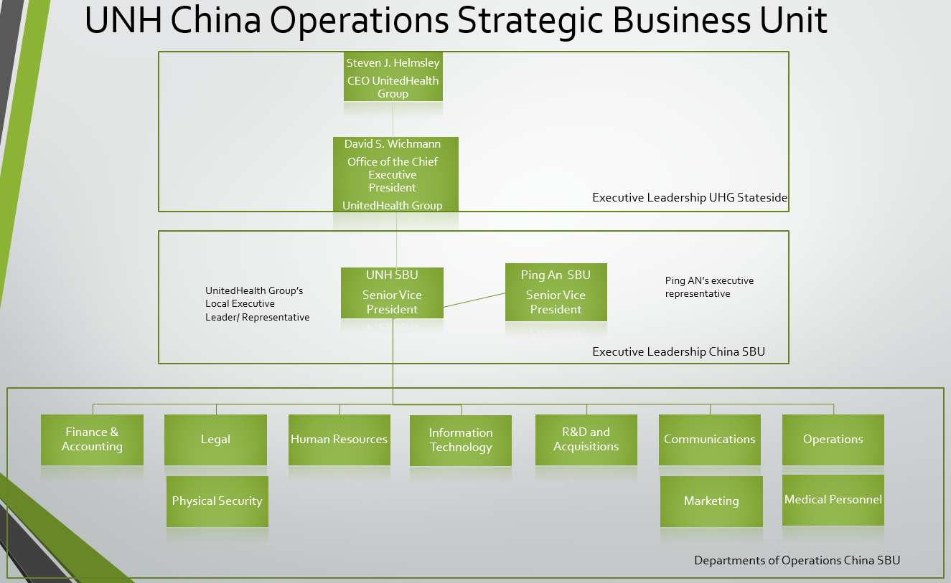
Figure 1. UNH China Operations SBU Org. Chart
From there the management team consisting of a Manager, Assistant Manager and Supervisor will work together to translate the directives into tactical operations and ensure that the mission is carried out by the employees. The departments Accounting & Finance, Human Resources, Information Technology, R&D and Acquisitions are singular departments without sub divisions and as such their leadership structure will consist of one VP, a Manager, an Assistant Manager a Supervisor and employees, see figure 2.
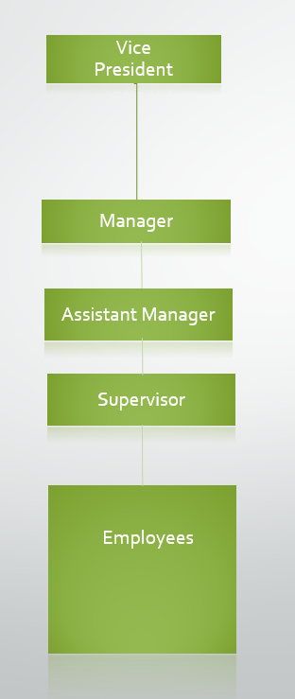
Figure 2. UNH SBU Management Chain
For the other 3 divisions: Legal, Communications, and Operations, there are subdivisions meaning that they have more than one division answering to one VP. For instance, in the case of Operations we have two subdivisions namely, Medical Operations and Support Operations reporting to the VP of Operations, see figure 3. Each division will have its own Manager, Assistant Manager, Supervisor and employees.
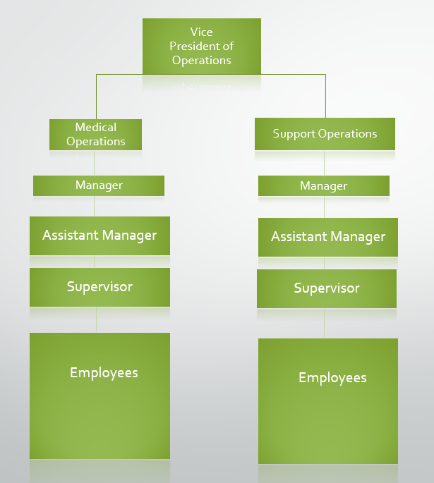
Figure 3: Operations Division Org. Chart (Subdivisions)
Roles and Responsibilities
UNH Senior Vice President- This position will be held by a member of HQ who will be responsible for the vision, strategy and action of the China SBU and for managing the business relationship that will exist between UNH and Ping An. The Senior Vice President will answer to the President of United Health Group.
Ping An Senior Vice President- This position will be held by an employee of Ping An who along with the UNH SVP will be responsible for representing the interests of both companies in the decisions that they make for the SBU in China.
Division Vice President- These individuals will chair each division and will answer directly to both SVPs. The will receive their orders from the SVPs to translate them into action.
Manager- This position will be the senior manager for the respective division and will answer directly to the Division’s VP. The manager is the liaison between the management of personnel and the day to day activities and executive leadership
Assistant Manager- This position will assist the manager in the day-to-day operations of the division. This individual is responsible the human resources function of the division and for interfacing with other divisions when necessary.
Supervisor- This position is directly responsible for the service and personnel that belongs to the division. This position is the first line of interaction between leadership and the employee.
Division of Labor
There are 7 departments which will divide up the actions of this SBU. These departments are:
- Accounting & Finance- This section will be responsible for budgeting, forecasting, payroll, facilitating transactions between the consumer, the seller, and various business units, paying taxes, paying regulatory fees and book keeping for US and Chinese government compliance.
- Legal- This department will interface with both UNH and Ping An’s legal teams who will help to ensure that all actions by this SBU are legal and should any issue arise requiring litigation that the SBU will have fair representation.
Physical Security- This team will work to protect the mobile medical team, restrict site access and protect this SBU’s interests and assets.
- Human Resources- This team will be responsible for hiring and personnel actions on the behalf of the employee in relation to the SBU.
- IT- This section will be responsible for network communications for the SBU in compliance with local regulations and between UNH and Ping An.
- Research and Development and Acquisitions- This division will be responsible for research, mainly conducting surveys to gauge the population, to develop and provide the best possible products and services to the consumer.
- Communications- This business unit will be responsible for crafting the message that the public and shareholders will receive. They are also responsible for marketing.
Marketing- This business unit will be responsible for taking the needs of the public, delivered via the R&D department, mixing it with the offerings of UnitedHealth Group, packaging it, and presenting it to the public
- Operations- This business unit is responsible for the “boots on the ground” actions of UNH comprising of the mobile clinic employees and our customer service representatives.
Medical Personnel- This medical team is comprised of 4 doctors, 8 nurses, and 3 support personnel that will be deployed all over the country in the mobile clinic. There will be 2 teams in the first year of this expansion.
Support Personnel- This team will be responsible for interfacing with the public. They will be responsible for sales and customer service. Should this team be overwhelmed Ping An’s local sales and customer service teams will have overflow teams who can support them.
Personnel Pay and Startup Costs
The majority of the individuals that we hire to fill these positions will either be skilled individuals from Ping An’s human capital or will be hired locally with the exception of the following positions and the respective number of positions: UNH Senior Vice President (1), Vice President (7), Senior Managers (10) and Middle Managers (10) all of whom will come from UNH’s stateside operations.
Senior Vice President: Salary of $200,000. There will be two Senior Vice Presidents for a total cost of $400,000 annually.
Vice President: Salary of $150,000. There will of 7 individuals in this position for a total of $1,050,000.
Senior Manager: Salary of $130,000. There will be 10 of these positions in this SBU in China accounting for a total cost of $1,300,000.
Assistant Manager: Salary of $87,309.60. There will be 10 Assistant Managers for a total cost of $873,096 per year.
Supervisors: Salary of $61,116.72. There will be 10 supervisors for a total cost of $611,167.2 per year.
Employees: Salary of $43,654.8. There will be a total of 45 employees for a total cost of $1,964,466 per year.
Mobile Clinics: Two mobile clinics for $350,00 fully equipped, for a total of $700,000. We will assign 4 doctors, 8 nurses, and 3 support personnel to each clinic.
Mobile Clinic Staff’s Salaries
Doctors: Salary of $96,000. There will be 8 doctors for a total cost of $768,000 per year.
Nurses: Salary of $50,000. There will be 16 nurses for a total cost of $800,000 per year.
Support Personnel: Salary of $30,000. There will be 6 support personnel for a total cost of $180,000 per year.
The total startup cost for the Mobile Clinic Service will be $2,448,000. If we calculate in the costs for supplies at about $52,000 we will spend $2,500,000 in the first year in equipment and salaries. In the second year, the cost of operating the mobile clinic will decrease by $700,000 bringing the operating costs to $1,800,000, however, the costs of vehicle maintenance will likely increase in subsequent years due to wear and tear on the vehicles.
Overall the startup costs for supplies and personnel will be $8,646,729.2. After year 1, the operations cost will reduce by $700,000, provided that salaries remain constant and that no further expansions are implemented. This would bring the operational costs for year 2 to $7,946,729.2. What has not been calculated into these costs are the regulatory, insurance, license, and permit fees and taxes for the year. Some of these are a one-time expenditure and will therefore not count against the operational costs for the subsequent years.

In-Country Marketing Plan

Product, Promotion, Pricing Strategy and Placement
There are no product modifications needed for UNH to enter the Chinese market. Currently, UNH provides customers with a range of policies from which to choose. Each client can customize his policies and plans to accommodate his needs.
Since UNH is looking to partner with Ping An Health in a Joint Venture, the two companies will share some of the promotion costs. First, UNH and Ping An Health will provide internet, magazine and newspaper advertisements promoting the new venture with the brunt of this endeavor falling onto the native corporation to ensure the wording and look are appropriate to best influence the indigenous community.
Secondly, UNH will leverage Ping An’s existing relationships to partner with the Chinese government with the goal being to receive an official endorsement as a way to gain market acceptance in China. A good relationship with officials will not only assist in promoting the company within the Chinese population but also increase UNH’s reputation with local competitors.
Third, to reach the millennial market share, UNH will create a promotion campaign that focuses on the family bond. This bond is an integral part of Chinese culture and UNH will emphasize its existing plans that provide discounts for family members and multi-person policies. The advertisements will focus not only on appealing to the traditional family unit of husband, wife, and children but will also include grandparents, aunts, uncles, and cousins.
To keep start-up costs down until UNH has a solid market share, UNH will sell policies and plans to the Chinese market through a newly created joint office with a direct sales force staffed with Ping An Health and UNH employees. The ideal would be to reach out to the native Chinese community through a direct sales force and the expatriate community through online sales. The online sales will continue to lean on UNH's existing infrastructure for the expatriate and English speaking communities. This proposal will best use the existing infrastructure of both companies efficiently. UNH will collaborate with Ping An to create a Chinese language website for later use with online sales for the native Chinese community.
Like the variety in the promotion and product placement, the recommend pricing strategy has multiple factors. For the Diabetes-specific native Chinese policies, UNH will utilize penetration pricing. UNH will set the initial price low for all diabetes-specific policies, medicines, and devices with the goal of attracting customers and gaining market share. The price can be raised later once UNH has gained market share and a firm foothold. A business that uses a penetration pricing strategy prices a product or a service at a smaller amount than its usual, long range market price to increase more rapid market recognition or to increase their existing market share (Kent, 2003).
Firms or businesses usually use the penetration pricing strategy when entering a new market. In marketing, it is a theoretical method that is used to lower the prices of the goods and services causing a high demand for them in the future (Spann et al., 2014). This strategy of penetration pricing is highly recommended due to the enormous amount of competition in the Chinese health-care market. Due to this situation, UNH will use the penetration strategy to gain consumer attention (Spann et al., 2014).
For the millennials, UNH will utilize relationship marketing to help with the pricing strategy. Abramson and Aihave identified shared values or goals as some of the key aspects of relationship marketing (Abramson et al., 1997). UNH will build on the family oriented promotions with providing family specific pricing. Most millenials, are of good health and have few medical expenses. However, many are supporting older generations and extended family members that are experience health issues.
Also for the millennials, UNH will use Price discrimination. This pricing strategy is the practice of setting a different price for the same product in different segments to the market. Specifically, UNH will utilize second-degree price discrimination. The second-degree strategy provides a volume discount to high-frequency buyers (Chang & Chen, 2016). This practice encourages the purchase of more items to increase the discount. UNH will offer customers of multi-person or multi-focused policies a price range that will decrease the per-person costs as more items are purchased.
Marketing Costs
When it comes to marketing, the saying “spend money to make money” couldn’t be truer. The health insurance industry is no exception, either. According to the American Marketing Association (AMA), particularly in the insurance industry, revenue growth is directly tied to the amount spent on marketing, regardless of the size of the firm (Conick, 2016). The AMA also notes that companies who spend at least 15% of their revenue on marketing tend to see a 20% year over year increase in revenue. UNH will aim to follow a similar plan, and initiate aggressive marketing and advertising campaigns to foster explosive growth in the new Chinese market. Although they may not need to match the $169 million spent on advertising in 2013, due to splitting efforts with Ping An Insurance in the joint venture (JV), they still will not shy away from excessive spending in the first few years in the new market to capture market share (Flory, n.d.).
Product Modifications
There will be no product modifications needed, thus none of these costs are associated with the marketing plan expenses.
Distribution Costs
Distribution costs will be incurred through the use of a direct sales force for both physical and online sales. All of the 9 key sales personnel will take some sort of alternating role in both physical sales and back office sales, eliminating the need for a call center. For physical, the JV will provide three reps available in the office during business hours, and two reps always in the field doing road shows or presentations twice a week. At the start, each team member will be provided 12 company branded polo shirts ($360), 2000 business cards ($80), a leather briefcase ($200), a laptop ($1,200), a cell phone ($200), and a $1,000 allowance for miscellaneous items per month (entertaining clients, etc.). Additionally, we will need to add in the monthly cell phone service ($100), annual business card re-stock ($80) and monthly allowance ($1,000) in ongoing costs per employee. For the online space, the company will require a professional website capable of processing sensitive personal information. UNH will contract a private company for the design, maintenance and support of this website for a startup cost of $12,000 upfront and ongoing fees of $1,000 a month. Additionally, phone services and dedicated internet will be relied on heavily for all personnel. UNH will contract with a local ISP to procure VoIP phone services and a dedicated 50 megabyte Ethernet internet circuit for $3,000 initially and $1,800 per month thereafter. Final costs for the distribution aspect total $184,760 to startup and $170,760 ongoing per annum. Major assumptions made in this portion include replacing branded shirts, briefcases, laptops and cell phones on an annual basis, with the old items being recycled or donated to a non-profit for a tax credit.
Advertising/Promotion Costs
UNH will rely on several advertising and promotion related materials that promote their theme of “family bonding”. Utilizing Vistaprint, UNH will obtain 1,200 brochures ($600) and 100,000 post cards ($3,500). Additionally, they will buy magazine ($800), newspaper ($400) and internet ($500) advertising slots on a monthly basis. This brings the total startup costs for advertising and promotion to $24,500, and the same amount for ongoing costs.
Sales Incentives/Rewards
The sales team will be compensated heavily in salary, and therefore will not be allowed to draw commissions on policy sales. However, UNH will give out quarterly bonuses at each review period, where sales employees will be allowed to earn up to 25% of their salary as a one-time bonus. The current sales team salary is a total of $469,081.12 for all nine employees. As 25% of this amount is available four times a year, that gives us a grand total equal to their combined salary ($469,081.12 *0.25 * 4) in incentive money at startup and ongoing.
Marketing/Sales Headcount
The marketing/sales headcount has already been established, and will not be included twice in this analysis. However, for reference, the salaries of the 9-member sales team are as follows:
- Division Vice President: $147,000 per year
- Senior Manager: $130,000 per year
- Assistant Manager: $87,309.60 per year
- Supervisor: $61,116.72 per year
- Employees/Sales Reps (5): $43,654.80 per year
- Total: $469,081.12 per year
Target Segment’s Market Size in Units and Dollars
Market share can be determined by units sold, customers served or dollar volume (Peterson et. Al, 2014). Unit market share measures the percentage of units sold by a company compared to total units sold in the market, while revenue market share measures the revenue of a company compared to total revenue in the market” (Boundless, 2017). Customer market share measures a company’s percentage of the market compared to that of the entire market.
To determine customer market share and revenue market share volume, we will use the following formulas against our two target markets, diabetes sufferers and Millennials:
- number of target customers x penetration rate = Market Volume, &
- market volume x average value= Market value
Diabetes
In 2016, 110 million Chinese citizens suffered from diabetes. Diabetes comes in two forms, type 1 and type 2. Additionally, almost 500 million more suffer from“prediabetes” (Sjolin, 2016). Being prediabetic poses a risk factor for developing type 2 diabetes (WHO, 2016). If we add just 25% (125 million) of the 500 million prediabetic citizens to the current number of diabetics, the number of diabetics in China would more than double to 235 million. Notwithstanding, China is expected to have more than 151 million people with diabetes by 2040 up from their current number of 110 million (Sjolin, 2016).
Target Market- Based on the 2016 numbers of total diabetes sufferers, we will estimate our number of target customers at 110 Million. Based on the 2040 numbers, our 2nd set target customers will number 151 million. As mentioned before should 25% of the prediabetic population become diabetics we can see the current number of 110 million balloon to 235 million diabetes sufferers.
Penetration rate- For our target penetration rate, we will go with 5 percent because diabetes coverage is in high demand due to the current gaps in healthcare coverage as well as the desire of individuals not to lose their life savings to healthcare issues. This can be considered mission critical although a service such as this is not mandated. If marketed based on the dire threat that diabetes pose to Chinese citizens it is reasonable to aim for 5% market share above the modest 1% being used for our millennial market volume.
Market Volume- Using the 2017 numbers of current diabetes sufferers (110 million), if UNH can gain just 5% of the market with their supplemental diabetes insurance UNH can have 5.5 million customers in this niche market alone. By 2040, if projections remain constant, UNH can have 7.5 million customers, and in the event that 25% (125 million) of prediabetics become diabetic the customer share (at 5%) can reach 11.7 million customers.
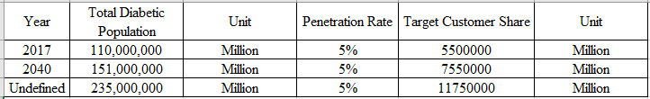
Table 1. 2017, Projected 2040, and undefined Diabetic Population with respective target customer share
China’s Diabetic Insurance Market Value
The market size (value) is determined by the formula market volume x average value= Market value. UNH’s 2017 market volume is 5.5 million customers, when multiplied by the cost of each unit of sale $450 (annual) the product is a market value of 2.47 Billion dollars. Of course, this increases when calculating in the projected total customer share in 2040 ($3.39 billion) and the potential 25% of the prediabetic population ($5.28 billion) shown in table 2.
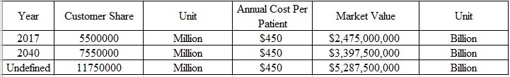
Table 2. China’s Diabetic Market Value for 2017, 2040 and undefined
Type 2 Diabetes projections
UNH can further segment the diabetes market to type 2 diabetics. In the next three to five years the type 2 diabetic population is expected to grow from 55 million to 60 million in 2020, to 70 million by year 5 (2022). Given a penetration rate of this market at 5% the target market volumes are 2.75, 3.0, and 3.5 million customers respectively.
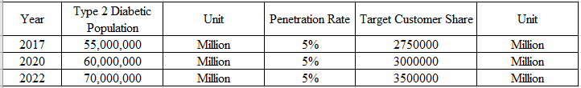
Table 3. 2017 Type 2 diabetes sufferers, Projected 2020 and 2022 type 2 diabetics, their penetration rate at 5% and each year’s respective target customer share
Taking those market share numbers and multiplying them against the annual cost per patient of $450, the market values are $1.2 (2017), $1.3 (2020), and $1.5 billion (2022).
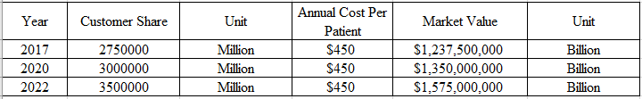
Table 4. 2017 Type 2 diabetes sufferers, Projected 2020 and 2022 type 2 diabetics, their penetration rate at 5% and each year’s respective target customer share
Millenials
Currently the millennial population (those between 18 and 35 years of age) in China is 385 million(Russell, 2016). The number of millennials in China is expected to reach over 400 million by 2020. The middle class is projected to number 630 million by 2022 but how many of this number are millennials has not yet been discovered and as such no projections are available at this time.
Target Market- The number of target customers (market) for 2017 is 385 million people. The target customers projected for 2020 is 400 million people.
Penetration Rate- The target penetration rate, is low due to the fact that this product is not mission critical nor is it mandated through regulation and also because it is a product with a specialized purpose (Marsdd, n.d.). The market penetration rate is 1%.
Table 5. 2017 millennial population, Projected 2020 millennial population, their penetration rate at 1% and each year’s respective target customer share
Market Volume- Using the 2017 numbers of millennials (385 million), if UNH can gain just 1% of the market with our insurance products and services we can serve 3.85 million customers. For 2020 (400 million projected), UNH could potentially server 4 million millennials.
Market Value
The customer share for 2017 is 3.85 million multiplied by the annual cost per patient of $450, the market value is $1.73 billion. The customer share for 2020 is 400 million multiplied by the annual cost per patient of $450, the market value is $1.8 billion. 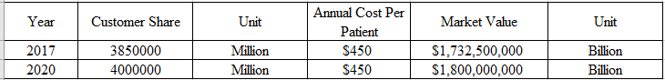
Table 6. 2017 millennial customer share, Projected 2020 millennial customer share, their annual cost per patient at $450 and each year’s respective market value

Financial Value

Revenue Forecasts and Assumptions

Assumptions
- We project a strong economy with continuous growth (no recessions).
- We project the Total Diabetic Population will grow yearly.
- We assume a 5% penetration rate in Diabetic insurance and a 1% penetration rate in Millennial insurance.
- We assume that there will be no unanticipated changes in economic policy that would make our services obsolete.
- We assume industry tax and interest rates remain relatively low.

Explanation
In developing the revenue forecast model there are many factors that must be accounted for. The revenue forecasting model is determined by using 10 percent of the target market for diabetic and millennials (pre-diabetic and diabetic). We then proposed that UNH would penetrate the markets at a very low percentage to ensure UNH hits the target marks within the first five years of operation.

Figure 1: Millennial Market Value
 | Millennials
 | Year
 | 2017 | 2020 | 2022
Total Millennials Population | 385,000,000 | 400,000,000 | 410,000,000
Penetration Rate | 1% | 1% | 1%
Target Customer Share | 3850000 | 4000000 | 4100000
Annual Cost Per Patient | $450.00 | $450.00 | $450.00
Market Value | $1,732,500,000.00 | $1,800,000,000.00 | $1,845,000,000.00

Figure 2: Diabetic Population Market Value
 | Diabetic Population
 | Year
 | 2017 | 2020 | 2022
Total Diabetic Population | 110000000 | 115347826.1 | 118913043.5
Penetration Rate | 5% | 5% | 5%
Target Customer Share | 5500000 | 5767391.304 | 5945652.174
Annual Cost Per Patient | $450.00 | $450.00 | $450.00
Market Value | $2,475,000,000.00 | $2,595,326,086.96 | $2,675,543,478.26

According to our assumptions, we anticipate that China’s economy will remain strong with continuous growth. This is a key factor for UNH to succeed in China. While there is no way to ensure the market will grow, we do have previous year projections which show rapid growth in the diabetic community within China. Tax and industry interest rates typically go up and down which may potentially cut into our yearly revenue. We think the amount of revenue gained (per year) could withstand any industry peaks or troughs in tax or interest rates.
Our projections were made in concurrence with industry data. We feel really confident about our revenue forecasts and anticipate growth over the next five years which could propel us into new markets or essentially provide the capital to extend our target population.

Cost Forecasts and Assumptions

Assumptions
- There are no inflationary changes in the year of the forecast.
- There are no deviations from the projected units to be sold in the year of the forecast.
- No employees were laid off, and no one was hired.
- The cost of goods sold (COGs) is at 25% of the particular product revenue.
- All costs are relevant including the startup costs. This means the cost projection is inclusive of all the startup costs.
- United Health Group Inc. does not introduce any other product line.

Explanation
From the above assumptions, a reasonable and concrete projection of all costs that the organization needs to run a one-year operation effectively can be made.

Several factors are held constant for the forecasting model, however, this does not mean that in reality, the factors will be at a constant.

Figure 1.1: Cost Projection
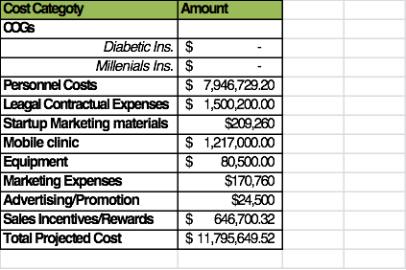

Figure 1.2: Units Sold
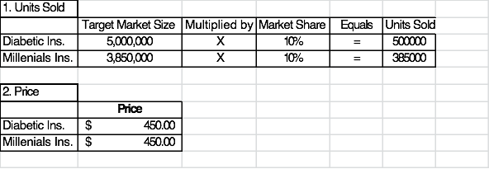
The above tables provide a graphical presentation of the analysis that was done. Figure 1.1 shows the categories of costs to be forecasted and their forecasted or projected values. Figure 1.2 shows the products amounts (in units) that are expected to be sold in the period of one year and their prices. To come up with a projection of the units, the percentage market share was multiplied with the total target market population. The two products being sold, Diabetic Insurance and Millennials Insurance, and their prices are indicated in figure 1.2.
The cost of goods sold was estimated at 25% of the total sales price of each product, translating to a 25% share in the product revenues projected. Some factors such as inflation are held constant. I
t is expected that there might be some little deviation of the real cost from the forecast values depending on various factors as listed below.
- Changes in personnel either through promotions, demotions, turnover, and layoffs, etc.
- Changes in price levels will affect the forecast values since the cost of goods sold will be negatively impacted.
- Miscellaneous expenditures may not have been taken care of fully.

Financial Results
Analytic instruments assess corporate financial performance by giving a summary of how the business incurs its revenues and expenses through both operating and non-operating activities. These tools also show the net profit or loss incurred over a specific accounting period, typically over a fiscal quarter or year (Helfert, 2002). The income statement analysis provides valuable insights into how effectively management is controlling expenses and investment (Helfert, 2002).
Ratios calculated using the income statement provide information on the profitability of a company and the efficiency of the enterprise. The Gross Profit Margin and the Pretax Profit Margin give a snapshot on the profitability of the business; on if the corporation is moving in a direction that is earning money or losing it (Helfert, 2002).
The Gross Profit Margin is determined by dividing the Gross Income by the Total Revenue. The Pretax Profit Margin is determined by dividing the Income before Taxes by the Total Revenue. These margins explain the amount of earnings received by the company that is profit.
The Gross Profit Margin remains steady of the projected 6-year time span at .98. This means that for every $1.00 spent by UNH, $.98 are gross profit for the corporation. The pretax profit margin slightly increases over time from .96 to .97.

Balanced Scorecard

[Placeholder – Section 17 - Balanced Scorecard – Week 11]

Conclusion

[Placeholder – Section 18 - Conclusion]

*** The final team project paper should be approximately 30 pages, exclusive of cover page, appendices and references. ***

Reference List

About United Family Healthcare. (n.d.). Retrieved March 2, 2017, from http://ufh.com.cn/about-ufh/
About Value-Based Care. (n.d.). Retrieved February 08, 2017, from https://www.uhc.com/valuebasedcare/about-value-based-care
Ashmore, C. (2011) US healthcare firm United Health Group may expand Letterkenny operations, retrieved on July 7, 2011 from http://www.irishtimes.com/newspaper/finance/2011/0520/1224297354260.html
Barnett, J. C., & Vornovitsky, M. (2016, September 13). Health Insurance in the United States: 2015. Retrieved February 09, 2017, from http://www.census.gov/data/tables/2016/demo/health-insurance/p60-257.html
Beckland, R. (2016, June 23). Healthcare Innovation: How 2016 trends are already evolving. Retrieved February 09, 2017, from http://www.healthcareitnews.com/sponsored-content/healthcare-innovation-how-2016-trends-are-already-evolving
Carlstrom, C. T. (1994). "The Government's Role in the Health Care Industry: Past, Present, and Future," Federal Reserve Bank of Cleveland, Economic Commentary, 06.01.1994. Retrieved from https://www.clevelandfed.org/en/newsroom-and-events/publications/economic-commentary/economic-commentary-archives/1994-economic-commentaries/ec-19940601-the-governments-role-in-the-health-care-industry-past-present-and-future.aspx
Dain, K. (2015). Prioritizing Health and Non- Communicable Diseases in the Post-2015 Development Agenda. Georgetown Journal Of International Affairs, 16(2), 165-173.
Deu, F. L., Parekh, R., Zhang, F., & Zhou, G. (2012, November). Health care in China: Entering 'uncharted waters' Retrieved February 09, 2017, from http://www.mckinsey.com/industries/healthcare-systems-and-services/our-insights/health-care-in-china-entering-uncharted-waters
Economic Data and Trade Statistics. (n.d.). Retrieved February 09, 2017, from http://brics.itamaraty.gov.br/about-brics/economic-data
Fortune 500. (n.d.). Retrieved February 08, 2017, from http://beta.fortune.com/fortune500/list/filtered?industry=Health Care%3AInsuranceandManaged Care
GHO | By category | Density per 1000 - Data by country. (2017, February 7). Retrieved March 05, 2017, from http://apps.who.int/gho/data/node.main.A1444
Global Strategic Choices. (n.d.). Retrieved February 09, 2017, from http://2012books.lardbucket.org/books/challenges-and-opportunities-in-international-business/s12-01-global-strategic-choices.html
Glucksman, J., Lipson, R. (2010). Private Healthcare a Tough Market to Crack. Retrieved from: https://www.chinabusinessreview.com/private-healthcare-a-tough-market-to-crack/
Health Care Providers & Services. (n.d.). Retrieved February 08, 2017, from https://eresearch.fidelity.com/eresearch/markets_sectors/sectors/industries.jhtml?tab=learn&industry=351020
Helms, M. M., & Nixon, J. (2010). Exploring SWOT analysis–where are we now? A review of academic research from the last decade. Journal of strategy and management, 3(3), 215-251.
Hoovers. (2011). Competitive landscape, retrieved on July 7, 2011 from http://www.hoovers.com/company/UnitedHealth_Group_Incorporated/rhffki-1-1njea3.html
How Value-Based Care Benefits You. (n.d.). Retrieved February 08, 2017, from https://www.uhc.com/valuebasedcare/how-value-based-care-benefits-you
Jiang, J. (2011, October 11). In Some Chinese Hospitals, Violence Is Out of Control and It's Doctors Who Are at Risk. Retrieved March 05, 2017, from http://content.time.com/time/world/article/0,8599,2096630,00.html
Kaiman, J., Smith, D., Anand, A., Watts, J., Kingsley, P., Hooper, J., Oltermann, P. (2014, October 29). How sick are the world's healthcare systems? Retrieved February 09, 2017, from https://www.theguardian.com/society/2014/oct/29/how-sick-are-worlds-healthcare-systems-nhs-china-india-us-germany
LaMonica, P. R. (2016, April 19). UnitedHealthcare to exit most Obamacare exchanges. Retrieved February 09, 2017, from http://money.cnn.com/2016/04/19/investing/unitedhealthcare-obamacare-exchanges-aca/
Maverick, J.V. (2016). 5 alternatives to traditional health insurance. Retrieved from http://www.investopedia.com/articles/personal-finance/021016/5-alternatives-traditional-health-insurance.asp
Morello, R. (n.d.). Legal and Cultural Issues of Marketing in a Foreign Country. Retrieved from http://smallbusiness.chron.com/legal-cultural-issues-marketing-foreign-country-58165.html
NYSE:UNH (2011) UnitedHealth Group Inc., Google Finance, retrieved on July 7, 2011 from http://www.google.com/finance?q=NYSE:UNH
Pickrell, R. (2016, August 16). Why Gov’t-Run Healthcare Has Become A Focal Point For Vigilante Violence In China. Retrieved March 03, 2017, from http://dailycaller.com/2016/08/16/why-govt-run-healthcare-has-become-a-focal-point-for-vigilante-violence-in-china/
Shobert, B. (2016). What Healthcare Companies Looking to Get Into China Must Know. Forbes 12-19-16. Retrieved from: http://www.forbes.com/forbes/welcome/?toURL=http://www.forbes.com/sites/benjaminshobert/2016/12/19/healthcare-companies-take-note-china-doesnt-need-you-as-much-as-you-think/&refURL=https://www.google.com/&referrer=https://www.google.com/
Smita, D. (2016). Global Health Insurance Market To Rise As Disposable Incomes Improve For Most Income Groups.
U.S. Department of Health & Human Services. (2013). Rights & protections. Retrieved from http://www.healthcare.gov/using-insurance/understanding/rights/index.html.
UnitedHealth Group (2011) About Us, retrieved on July 7, 2011 from http://www.unitedhealthgroup.com/main/AboutUs.aspx
UnitedHealth Group About." UnitedHealth Group. Web. 22 Sept. 2015.
UnitedHealth Group Form 10-K 2014." Hoovers Online Database. United States Securities and Exchange Commission, 31 Dec. 2014. Web. 21 Sept. 2015.
Wall Street Journal (2009) UnitedHealth Group acquired Health Net Inc., retrieved on July 7, 2011 from http://online.wsj.com
World industry outlook: Healthcare and pharmaceuticals, The Economist Intelligence Unit, September 2015.
WHRO. (2016). Rate of Diabetes in China “Explosive”: Healthy diet and exercise key to turning the tide. Retrieved fromhttp://www.wpro.who.int/china/mediacentre/releases/2016/20160406/en/
Why Choose UnitedHealthcare? (n.d.). Retrieved February 08, 2017, from https://www.uhc.com/employer/why-unitedhealthcare

Appendix A
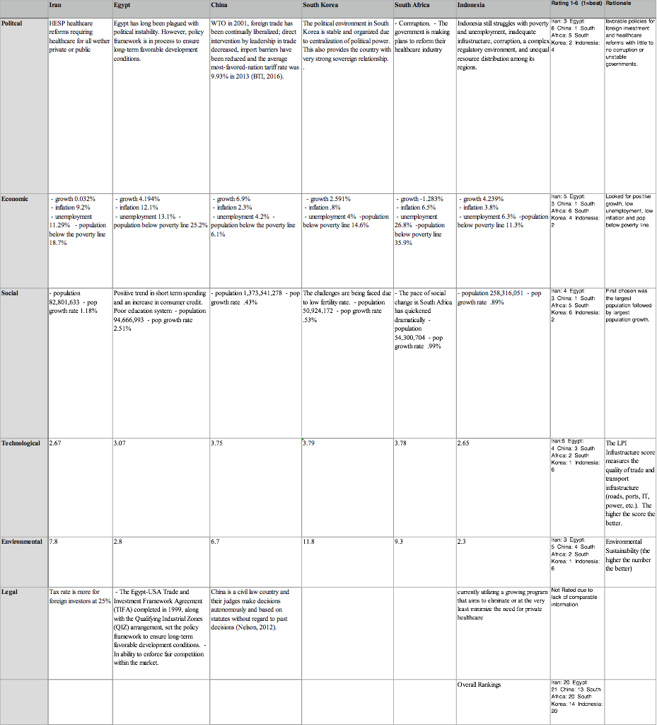

Appendix B
